**email campaign performance**

**Executive Summary**

# Objective

* To Evaluate key metrics   
  (open rates, CTR, conversions, unsubscribe rates)
* To Segment performance by campaign type.
* To Provide actionable recommendations to improve campaign effectiveness.

# Findings

# Details

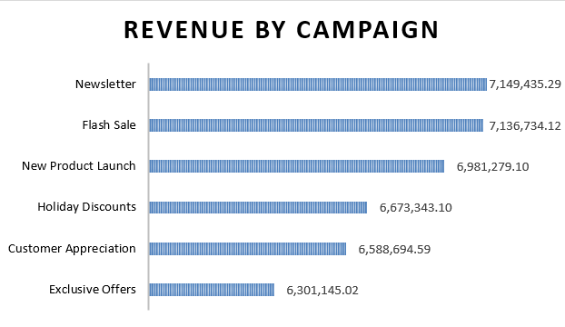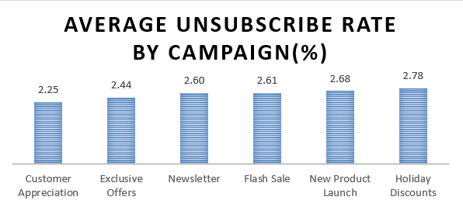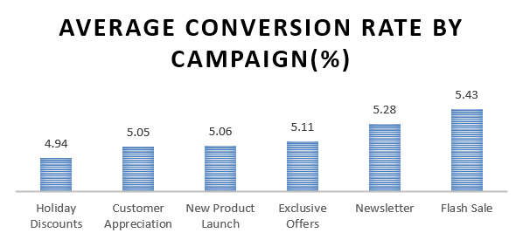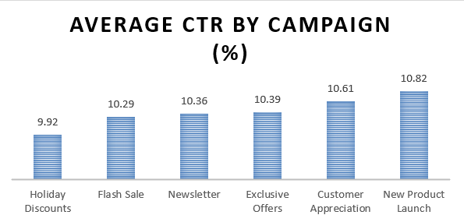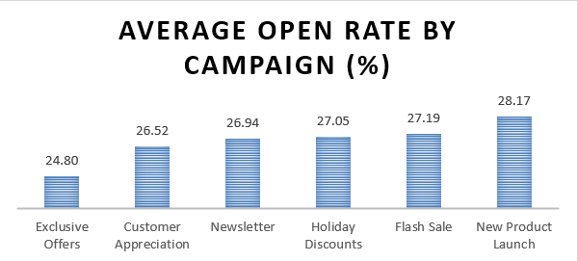

**Top performing Campaigns by Revenue**



**Open Rates**  
New Product Launch has the highest average open rate (28.17)

Exclusive Offers have the lowest average open rates (24.80)

**Click-Through Rate**

New Product Launch has the highest average CTR (10.82)

Holiday Discounts have the lowest average CTR (9.92)

**Conversion Rate**

Flash Sale has the highest average Conversion Rate (5.43)

Holiday Discounts have the lowest average Conversion Rate (4.94)

**Unsubscribe Rate**

Customer Appreciation has the lowest average Unsubscribe Rate (2.25)

Holiday Discounts have the highest average Unsubscribe Rate (2.78)

**Revenue Generated**

Newsletter & Flash sales have the highest revenue generated ($7,149,435.29, $7,136,734,12)

Exclusive Offers has the lowest revenue generated ($6,301,145.02)

# recommendations

The lack of correlation between open and CTR suggests that subject lines may be successful at achieving opens but the body of the email is not sufficient to inspire clicks.

Maybe the CTAs are not quality or the content is irrelevant upon opening.

Possible angles to consider: customer lifetime value, average order value, segmentation, personalization, and timing.

As conversion rates aren't a direct indicator of revenue, perhaps price points or product categories within successful conversion campaigns aren't most profitable.

Encouraging upselling or cross-selling could help. For campaigns with high unsubscribes, like Holiday Discounts, reducing frequency or targeting more precisely might help retention.

For Exclusive Offers, which have low revenue, perhaps the offers aren't perceived as valuable.

exclusivity or combining with limited-time offers could increase their effectiveness.

Prioritize recommendations that leverage existing strengths (like Flash Sales and Newsletters) while addressing weaknesses in underperforming campaigns.

• The number of emails sent is similar throughout all campaigns.

• New Product Launch emails have a higher chance of being opened.

• There is no relationship between open rate and CTR,

That would imply that open rate alone isn't a strong predictor of CTR.

• Flash sale-based campaigns have a higher chance of influencing the   
 client to take action.

• Customer Appreciation-based campaigns are better at making clients   
 less likely to unsubscribe.

• Exclusive Offers based campaigns don’t necessarily influence your   
 clients.

• There is no correlation between Conversion Rate and revenue,

That would imply that conversion rate alone isn't a strong predictor of   
 revenue.

# Key Insights

No relationship between open rate and CTR

No relationship between Conversion Rate and revenue

**Top performing by Unsubscribe Rate**



**Top performing by Conversion Rate**



**Top performing by CTR**



**Top performing Campaigns by Open Rate**

